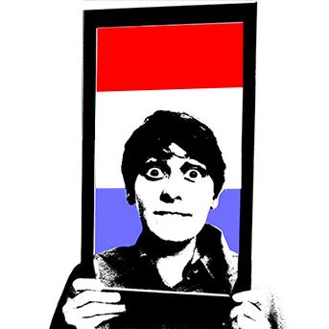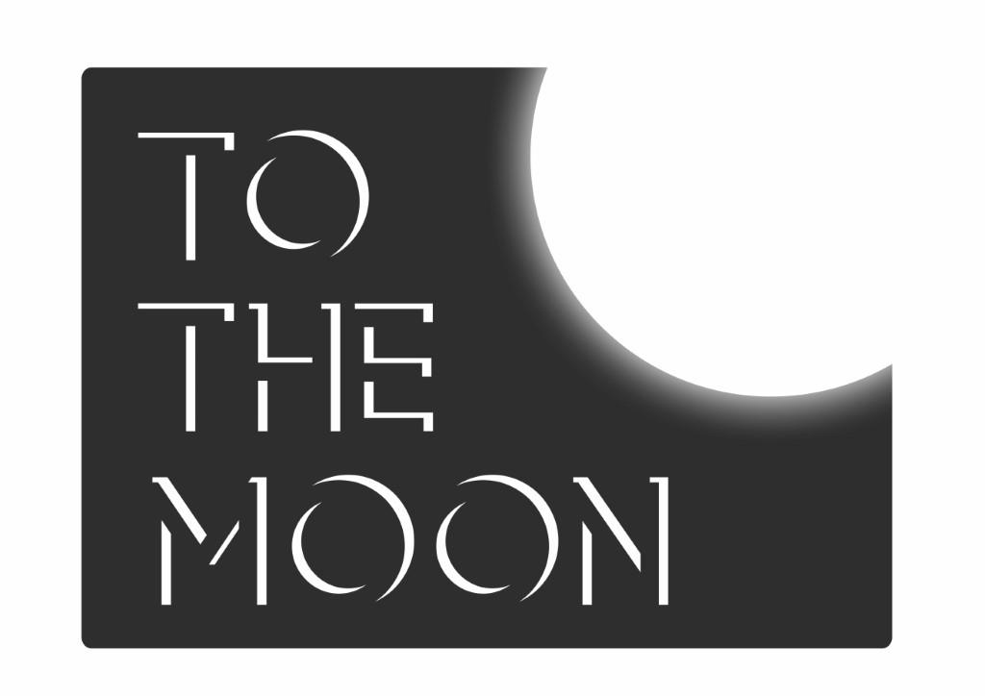

**PRESS RELEASE: 17.05.17**

For more information please contact

Sharon Burrell

Tel: 07881 912 580

Email: sharon@to-the-moon.net

COMPANY INFORMATION

*Arna Spek: Museum Piece* is produced by To The Moon. Founded by Sharon Burrell in 2012, To The Moon is all about getting women's voices heard this year, producing five female solo shows at Edinburgh Fringe as well as working with Barbadian poet / songwriter Ivy Davies, and vintage cabaret performer Peta Lily.

Stand-up comedian from the Netherlands, Arna Spek (BBC Radio 4 New Act Competition 2015 & 2017, Leicester Square Theatre New Act Semi Final 2016) is trying to blend in with the English! Will she succeed? Can she survive in Brexit Britain? Join Arna for an epic story, full of dangerously awkward moments.

Arna will be coming to Edinburgh fresh from supporting Simon Munnery, gigging with The Stand, and braving the weather at Brighton Fringe. She has just been awarded the 99 Club Bursary for Female Comedians. Museum Piece features a different guest artist every night.

**ARNA SPEK:**

**MUSEUM PIECE**

Written and performed by ARNA SPEK

JUST THE TONIC @ The Caves, Venue 88, Rowantree Bar

Edinburgh, EH1 1LG

**Listings Information**

**ARNA SPEK: MUSEUM PIECE**

Written and performed by Arna Spek

JUST THE TONIC @ The Caves, Venue 88, Rowantree Bar, Edinburgh, EH1 1LG

**3-13 15-26 August 2017**

**Midnight**

**Tickets £5 / PWYW**

**Box office:**

<https://tickets.edfringe.com/box-office>

Tel: 0330 220 1212

**Social media details:**

[tothemoon.net](http://www.to-the-moon.net/)

[@ToTheMoonUK](https://twitter.com/tothemoonuk)