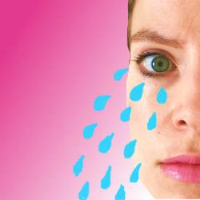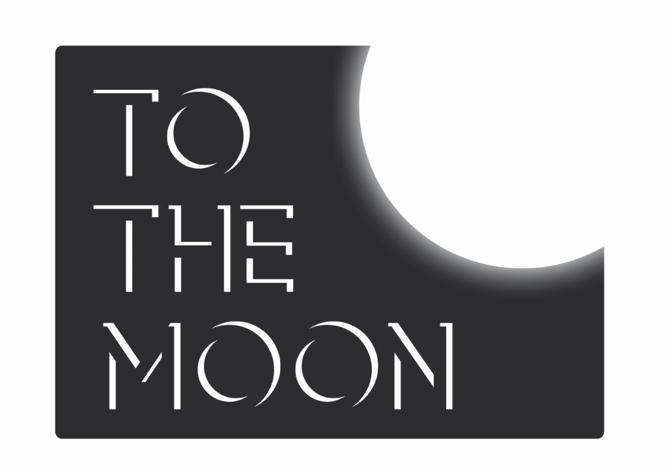

**PRESS RELEASE: 11.08.17**

**IT’S BETTER TO LIE THAN TO TELL THE TRUTH AND END UP ALONE IN A DITCH CRYING**

Written and performed by ELLEN WADDELL



Laughing Horse @ The Cellar Monkey, Venue 293, 15 Argyle Place

Edinburgh, EH9 1JJ

COMPANY INFORMATION

*It’s Better to Lie Than to Tell the Truth and End Up Alone in a Ditch Crying* is produced by To The Moon. Founded by Sharon Burrell in 2012, To The Moon is all about getting women's voices heard this year, producing five female solo shows at Edinburgh Fringe as well as working with Barbadian poet / songwriter Ivy Davies, and vintage cabaret performer Peta Lily.

Rock star turned comedian Ellen Waddell tackles the necessity of lying in life, love, friendship and when applying for administrative jobs at truck logistics companies.

Ellen spent most of her twenties playing bass for the indie pop band Los Campesinos! She started performing comedy in 2014 and her first one-person show, *Jean-Luc Picard and Me*, an autobiographical re-telling of a Star Trek obsession that left her trapped in a delicious fantasy world, sold out each of its runs in Bristol, before moving on to London and Edinburgh.

Ellen Waddell is a BAFTA x Crew member, a BAFTA and BFI hand picked list for up and coming film-makers in the UK. In 2015 she was awarded BFI funding to direct *Stages*, a short film written by herself, which has been selected for numerous festivals including The London Short Film Festival and the LOCO Comedy Festival, before being hosted on Comedy Central online.

Ellen’s first feature film is also in development. Titled *The Photographic Memory Recalls the Highlights of the Year*, it was co-written with Tom Betts for Western Edge Pictures and is based on her short story of the same title. She recently had a comedy residency at Glee Club, Cardiff, co-hosts popular nerd culture podcast, *Geek A&E* and hosts Q&A's and film events for The Watershed Cinema in Bristol. Ellen has most recently been shortlisted for Kevin Spacey Foundation funding for a short film.

For more information please contact

Sharon Burrell

Tel: 07881 912 580

Email: sharon@to-the-moon.net

**Listings Information**

**IT’S BETTER TO LIE THAN TELL THE TRUTH AND END UP ALONE IN A DITCH CRYING**

Written and performed by Ellen Waddell

Laughing Horse @ The Cellar Monkey, Venue 293, 15 Argyle Place, Edinburgh, EH9 1JJ

**3-13 15-27 August 2017**

**7:30 pm**

**FREE**

**Social media details:**

[ellenwaddell.wordpress.com](http://www.ellenwaddell.wordpress.com)

[@ellenstarbuck](mailto:@ellenstarbuck)

[To The Moon](http://www.to-the-moon.net/laugh-or-cry-at-edinburgh-fringe.html)

[@ToTheMoonUK](https://twitter.com/tothemoonuk)