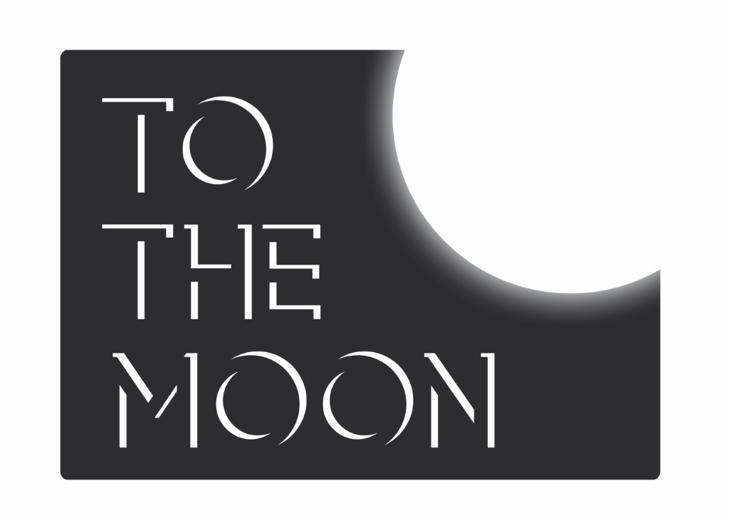

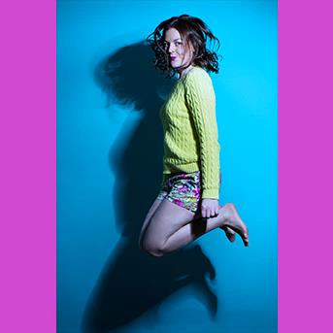

**PRESS RELEASE: 18.08.2017**

Fiona Sagar returns to the festival after her 2016 sell-out success Entitled, which was nominated for the Funny Women Best Show Award. This year she brings us Sagar Mega Drive – playing to sold out houses at The Free Sisters - including old favourite characters; Scottish Granny, Pippa Middleton and Ultimate LAD Mark, with newly welcomed additions; Substitute Teacher Margaret and Princesa the talking Chihuahua.

Plug in for hilarity and set your mode to multi-player. Sagar promises to be low on further gaming puns, high on character-based comedy.

Fiona Sagar is an actor, character comedian and improviser. She trained at East 15 Acting School and has trained extensively in improvisation with Monkey Toast, The Free Association, Second City and The Groundlings Comedy Theatre, LA. She has also trained in clowning with Dr Brown.

For more information please contact

Sharon Burrell

Tel: 07881 912 580

Email: sharon@to-the-moon.net

COMPANY INFORMATION

*Sagar Mega Drive* is produced by To The Moon. Founded by Sharon Burrell in 2012, To The Moon is all about getting women's voices heard this year, producing five female solo shows at Edinburgh Fringe as well as working with Barbadian poet / songwriter Ivy Davies, and vintage cabaret performer Peta Lily.

**SAGAR MEGA**

**DRIVE**

Written and performed by FIONA SAGAR

Laughing Horse @ The Free Sisters, Venue 272, 139 Cowgate,

Edinburgh, EH1 1JS

**Listings Information**

**SAGAR MEGA DRIVE**

Written and performed by Fiona Sagar

Laughing Horse @ The Free Sisters, Venue 272, 139 Cowgate, Edinburgh, EH1 1JS

**3-14 16-27 August 2017**

**4:30 pm**

**FREE**

**Social media details:**

@FiSagar

to-the-moon.net

[@ToTheMoonUK](https://twitter.com/tothemoonuk)