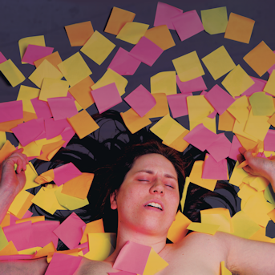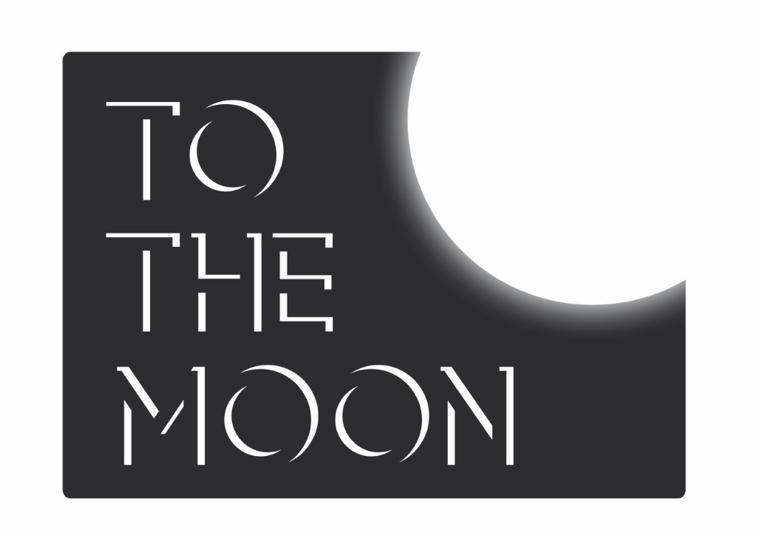

**PRESS RELEASE: 17.05.17**

**THE LOVE OF STATIONERY**

Written and performed by LISA MARIA BERG

JUST THE TONIC @ The Caves, Venue 88, Rowantree Bar

Edinburgh, EH1 1LG

COMPANY INFORMATION

*The Love of Stationery* is produced by To The Moon. Founded by Sharon Burrell in 2012, To The Moon is all about getting women's voices heard this year, producing five female solo shows at Edinburgh Fringe as well as working with Barbadian poet / songwriter Ivy Davies, and vintage cabaret performer Peta Lily.

**Listings Information**

**THE LOVE OF STATIONERY**

Written and performed by Lisa Maria Berg

JUST THE TONIC @ The Caves, Venue 88, Rowantree Bar, Edinburgh, EH1 1LG

**3-13 15-27 August 2017**

**Midnight**

**Tickets £5 / PWYW**

**Box office:**

<https://tickets.edfringe.com/box-office>

Tel: 0330 220 1212

**Social media details:**

[lisamariaberg.com/lisa](http://www.lisamariaberg.com/lisa)

[@LisaMariaNordic](mailto:@LisaMariaNordic)

[tothemoon.net](http://www.to-the-moon.net/)

[@ToTheMoonUK](https://twitter.com/tothemoonuk)

For more information please contact

Sharon Burrell

Tel: 07881 912 580

Email: sharon@to-the-moon.net

Naughty Nordic Noir for the midnight hour. Norwegian comedian and Lecoq graduate Lisa Maria Berg plays Woman – committed to orderly stationery displays and collecting irregular verbs – until a man turns her world upside down...

“I collect bags of sugar from cafes and restaurants I'm in. I have a big collection. Often I forget that I've taken them with me home and somehow, if you apply time and pressure, they have the tendency to explode …”

Lisa writes. On napkins, toilet paper, receipts, coffee filters and other pieces of paper. Most of these notes get lost. In 2015 Lisa acquired a USB stick. She's been trying to write things on her computer and save it on the new stick. To be more organised.

​

She's tried to assemble as many of the pieces as possible and make them into a one-woman show. This show is called

The Love of Stationery